Your text here

THE WORLDS BIGGEST SPORT

Abdul Wasay.Kalim.

24K-0744

THE WORLDS BIGGEST SPORT

SOCCER…FOOTBALL OR RUGBY



**_____**

**_____**

Your text here

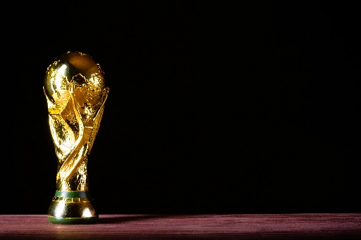

*Contents*

INTRODUCTION 2

History of Football 2

Early Years of Football 2

Growth and Development of Football 3

Popularity and Impact 3

Types of Football 4

Football and Technology 5

Football and Social Issues 5

Football and Health 5

FUTURE OF FOOTBALL 6

CONCLUSION 6

FIFA 7

# INTRODUCTION

Football, also known as soccer in some countries, is a popular team sport played between two teams of eleven players using a round ball with the objective of scoring more goals than the opposing team by kicking or heading the ball into the opponent's goal. It is one of the most widely viewed and played sports in the world, with an estimated 3.5 billion fans globally.

# History of Football

The modern version of football originated in Britain in the mid-19th century, with the first official rules being published in 1863. The Football Association was established in England in 1863, and the first international match was played between England and Scotland in 1872. The Fédération Internationale de Football Association (FIFA), the governing body of international football, was founded in 1904 and has since become the governing body for the sport worldwide.

# Early Years of Football

In the early years of football, the game was played with minimal rules and regulations. The first official rules were published in 1863, and they were designed to standardize the game and make it safer for players. The rules have undergone several changes since then, with the most significant changes being the introduction of the penalty kick in 1891 and the offside rule in 1925.

# Growth and Development of Football

Football gained popularity rapidly in the late 19th and early 20th centuries, with the establishment of national associations and leagues in many countries. The FIFA World Cup, held every four years, was first played in 1930 and has since become the most widely viewed sporting event in the world. The European Cup, now known as the UEFA Champions League, was established in 1955 and has become one of the most prestigious club competitions in the world.

# Popularity and Impact

# 

Football is not only a popular sport but also has a significant impact on society and the economy. The FIFA World Cup, held every four years, is the most widely viewed sporting event in the world, with over 3.2 billion people watching the 2018 tournament. Football has also been credited with promoting social cohesion, improving health and well-being, and generating significant revenue for local economies.

# Types of Football

There are several variations of football, including:

• Association Football: The most popular form of football, played with a round ball and eleven players on each team.

• Rugby Football*:* A full-contact team sport that originated in the UK, played with an oval ball and fifteen players on each team.

• American Football: A contact team sport played in the United States and Canada, with an oval ball and eleven players on each team.

• Futsal: A variant of association football played on a smaller field with five players on each team.

• Beach Soccer: A variant of association football played on a sandy surface with five players on each team.

• Indoor Soccer: A variant of association football played on a smaller field with six players on each team.

# Football and Technology

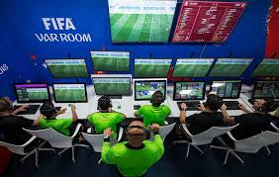The introduction of technology has had a significant impact on the game of football. The use of video assistant referees (VARs) has improved the accuracy of refereeing decisions, while the use of goal-line technology has helped to determine whether the ball has crossed the goal line. The use of data analytics has also become increasingly popular, with teams using data to gain a competitive advantage.

VIDEO ASSISTANT

# Football and Social Issues

Football has also been at the forefront of several social issues, including racism, sexism, and homophobia. The sport has been used as a platform to promote social change, with many players and teams using their influence to raise awareness about social issues.

# Football and Health

Football is a physically demanding sport that requires a high level of fitness and athleticism. The sport has been credited with improving health and well-being, with regular participation in football shown to reduce the risk of chronic diseases such as heart disease and diabetes.

# Future of Football

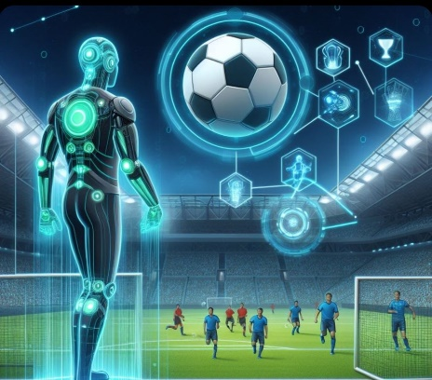The future of football looks bright, with the sport continuing to grow in popularity around the world. The introduction of new technologies and innovations is likely to continue to shape the game, while the sport's ability to promote social change and improve health and well-being is likely to remain an important aspect of its appeal.

# CONCLUSION

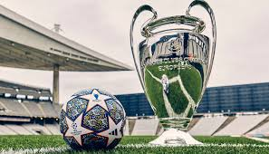Football is a sport that has captured the hearts of millions of people around the world. Its rich history, simplicity, and excitement have made it a beloved pastime for many. Whether played professionally or recreationally, football has the power to bring people together and promote social cohesion.

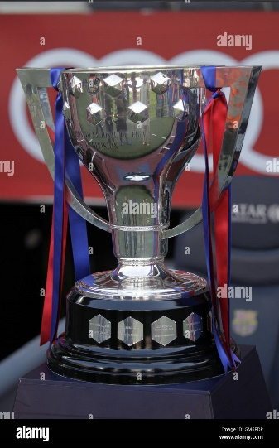

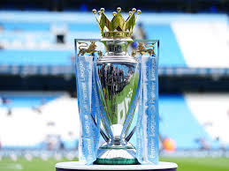

Some Major Competitions

Your here text

# FIFA

|  |  |  |
| --- | --- | --- |
| S.NO. | COUNTRY | FIFA WORLDCUPS |
| 1 | BRAZIL | 5 |
| 2 | GERMANY | 4 |
| 3 | ITALY | 4 |
| 4 | ARGENTINA | 3 |
| 5 | URUGUAY/FRANCE | 2 |

FIFA, or Fédération Internationale de Football Association, is the international governing body of association football, futsal, and beach soccer. Founded in 1904, FIFA is headquartered in Zürich, Switzerland, and has over 211 member associations worldwide. As the supreme governing body of football, FIFA is responsible for setting the rules of the game, organizing international competitions, and developing the sport globally. With a rich history and a commitment to promoting the game, FIFA has played a critical role in shaping the sport into what it is today. Despite facing several controversies and criticisms over the years, FIFA remains dedicated to its mission of developing the game and promoting social change through football.

COUNTRIES AND THEIR ACHIEVEMENT